July 2017 | Anderson Air & Heating | 804-231-6053  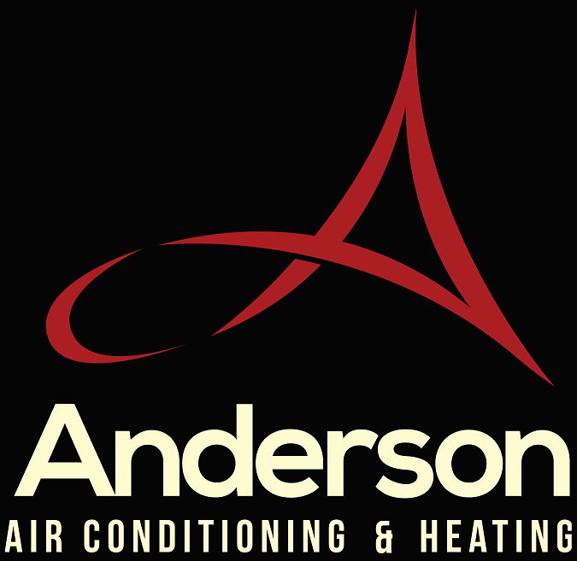  [Volume 1, Issue 1] | new products coming out and
Summer 2017 Newletter

THE HEAT IS ON! (the way)

Summer weather is upon us and Anderson Air Conditioning and Heating is ready to serve you! Richmond is expecting an unusually intense heat wave this year and we want you fully informed as a consumer and customer! In this issue we have some exciting news to share with you about where we will be out and about in the community so you can join us for some fun in the sun!

We also have an article on exactly what you can do as one of our valued customers to keep your system in ready mode so that you won’t have to be making that call for emergency service this season!

Further, we will bring to your attention services that Anderson does and what we are capable of doing for you. Including the addition of being able to service all Rinnai Tankless Water Heaters now! Their maintenance is just as important as your HVAC system! Special savings for our Eagle Home Owners!

Don’t forget to check the last page of the newsletter for valuable coupons you can use in case you need us for any reason and for some savings on our Preventative Maintenance Programs!

Contents
Special Interest Articles
Summer Heat is here 1
Watermelon Festival 2
Preventative Maintenance 3
About Us 4
Individual Highlights
History of Watermelon Fest 2
Interesting Watermelon Facts 2
What our tech does on a PM 3
Rinnai Tankless Water Heaters 3
Coupons & Contact Info 4
Come visit our booth at the WATERMELON FESTIVAL, Sunday August 13th!
2
The WATERMELON FESTIVAL in Carytown has been a staple in our urban tradition and we are so happy to be participating this year!
Not only will you meet our family but we can meet yours! We will have plenty of games, prizes and take home swag just for stopping by!
Our technicians will be on hand for you to ask any mechanical questions, as well as our office staff so can put a name to voices that you hear every time you call us.
Interesting Facts:  *The first watermelon harvest occurred over 5,000 years ago!  *Watermelon is both a fruit & a vegetable.  *A watermelon in 92% water.  *Watermelon is believed to be a natural remedy for sore muscles!  *The largest watermelon known weighed in at 268 pounds in Arkansas! | History of the Watermelon Festival!
 | 34th Annual Festival for Charity!
For 34 years, Richmonders have been attending this lively event because of the great music, food, vendors, fun and YES – Watermelons! But these are not your average watermelons. They are donated by the Shriner’s Organizations after they have been purchased from Martins and the proceeds benefit The Shriner’s Hospitals for Children.
With over 22 hospitals in North America, their sole mission to help treat children with illnesses that can be life threatening. The closest one to Richmond, in Greenville, SC, is currently treating hundreds of Richmond children who need it! Make sure to buy your bowl of juicy watermelon for only $1 to help support our community!
It is an event loved by adults and children alike as there is so much for everyone to do! We want to be there to support this historic event and our beloved city. We cannot wait to see you there!

3
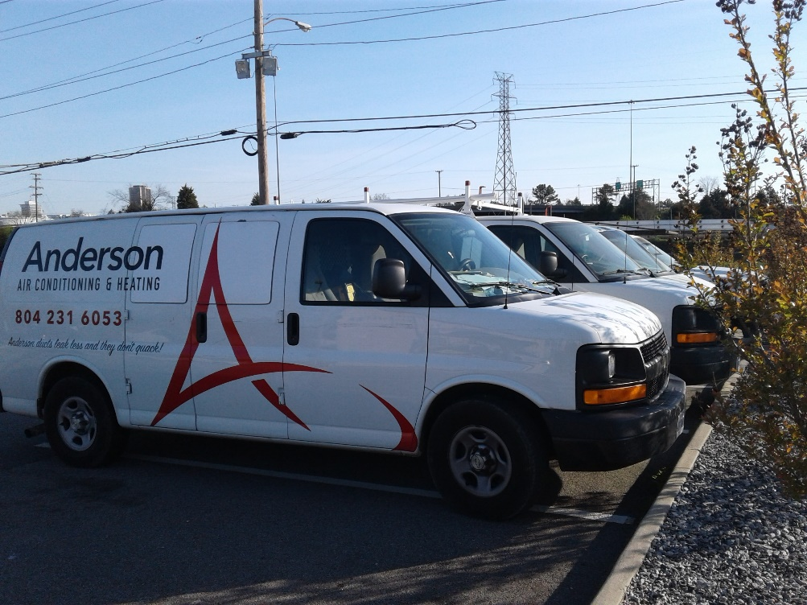 |  | Exactly what we do:  *Lubricate Motors  *Check Fan Belts  *Clean/Inspect Filters  *Check Evap Air Temps  *Check wiring & connections  *Check Refrigerant Charge  *Check Operating Pressures  *Check Voltage and AMP draw  *Clean/Flush drain line  *Clean Condensate Coil  *Check defrost operation  *Check system performance  *Check Pressure Switches  *Check Temp Differential  *Clean washable filters

Preventative Maintenance Program (PM)

Many people do not think about their HVAC system until it breaks down! Just like your vehicle, you’re A/C requires regular tune-ups in order to stay in optimized working condition. Our comprehensive PM service is exactly what you need to ensure you are not going to have unforeseen issues when you need cool air the most!
Our experienced and trustworthy technicians will be the ones who come out and perform this valuable service each year. While most of you are already on our semi-annual PM program, those who are not could really benefit from signing up and getting this done before the heat of summer knocks your system out of commission!
Our PM service is affordable and done right. The back of the newsletter will have 2 very valuable coupons on it for your convenience and savings. We recommend having your PM done twice each year. One should be done before turning your A/C on for the season and the second should be done before turning your heat on for the season. We will get you the peace of mind you need by getting a clean bill of health and priming your HVAC before starting it up! Call us today to set up your appointment at 804-231-6053!

RINNAI TANKLESS WATER HEATER MAINTENANCE IS HERE
Our technicians are now fully trained and capable of this valuable service!
Rinnai recommends having this done once per year for the life of your water heater. Go onto our website to access a special offer designed for Eagle Homeowners at www.andersonairheating.com
Please use the coupons below for your needs in the future! We are available for Emergency Repair calls 24 hours a day. While this service is valuable, you certainly don’t want to be in the position of needing it. Using the coupon below, schedule your Preventative Maintenance right away! In the event of an emergency, we have a coupon for that too! Have a safe and fun Summer and we will send you the Fall newsletter in August. In the meantime, remember:  “ANDERSON DUCTS LEAK LESS AND THEY DON’T QUACK!” | You may not need us now, but you will eventually!
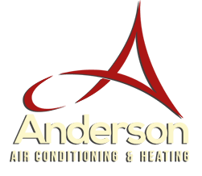
PREVENATIVE MAINTENANCE COUPON: Save $20 off any regularly priced PM Service
USE PROMO CODE: AND0100 – Expires August 31, 2017

SERVICE/DIAGNOTIC CALL COUPON: Save $25 off any regularly priced Service, Diagnostic or Emergency Service Call
USE PROMO CODE: AND0101 – Expires August 31, 2017

Anderson Air & Heating
1500 Bainbridge St.
Richmond, VA 23224
804-231-6053
804-233-5179
office@aacah.com
“Anderson Ducts Leak Less and they don’t Quack”
Find us on the Web:
www.andersonairheating.com

